Graham Avery elected Fellow of The Linnean Society
News from the Linnean Society

Graham Avery, Vice-Chairman of the Clarence Bicknell Association, was elected Fellow of The Linnean Society of London in May 2020.
Founded in 1788, The Linnean Society is the world’s oldest active biological society, taking its name from the Swedish naturalist Carl Linnaeus whose botanical, zoological and library collections are conserved by the Society at its home in Burlington House, London. The Linnean Society plays an important role in botanical research, and among the treasures in its Library are Clarence Bicknell’s publications Flowering plants and ferns of the Riviera (1885) and Flora of Bordighera and San Remo (1896).
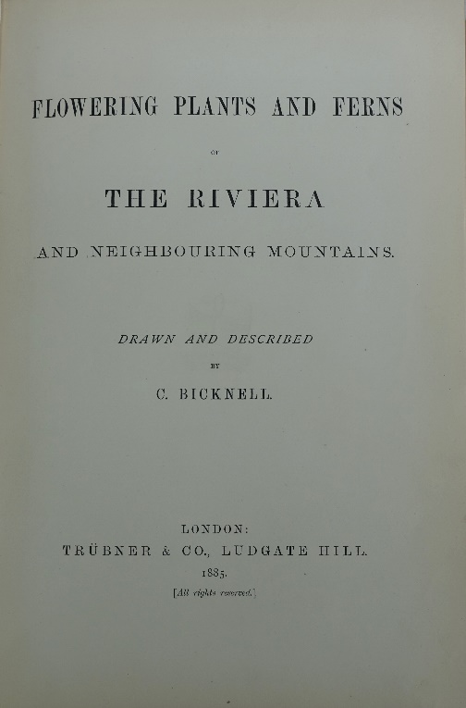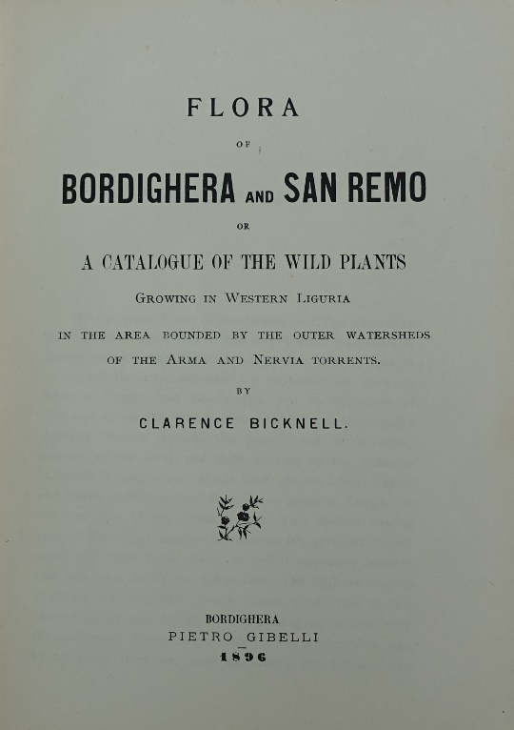

Many of Clarence Bicknell’s friends and associates were Fellows of the Linnean Society:
- H. Stuart Thompson and James W. White, botanists who stayed with Clarence at Casa Fontanalba, his summer home in the mountains – for more on them click here
- Frederick Townsend and Charles Edgar Salmon, botanists who corresponded with Clarence at his home in Bordighera
- Herman Bicknell (Clarence’s brother), soldier, scholar, explorer and mountaineer
- George Allman, whom Clarence thanked for help and encouragement in the Preface of Flowering plants and ferns of the Riviera, was a President of the Linnean Society
Clarence was a member of the Società Botanica Italiana, Italy’s equivalent of the Linnean Society, and was a friend of its President, Stefano Sommier, whom he visited in Florence.
Since the Clarence Bicknell Association was founded, Graham Avery has been active in research into Clarence’s botanical activities. He contributed the page on Clarence Bicknell the botanist to our website and more than twenty papers to our research documents section. Clarence’s correspondence with Emile Burnat, which Graham discovered in Geneva, was a key source for Valerie Lester’s ‘Marvels: the life of Clarence Bicknell’ published in 2018.
The Linnean Society’s ‘Adopt LINN’ scheme aims to support the preservation and use of its collections of specimens, books, manuscripts, artworks and artefacts. Under this scheme, Graham Avery financed the conservation of the Society’s copy of Clarence Bicknell’s book Flora of Bordighera and San Remo. Here is a photo of Graham with the repaired volume in his hands, taken by The Linnean Society’s Librarian Will Beharrell.
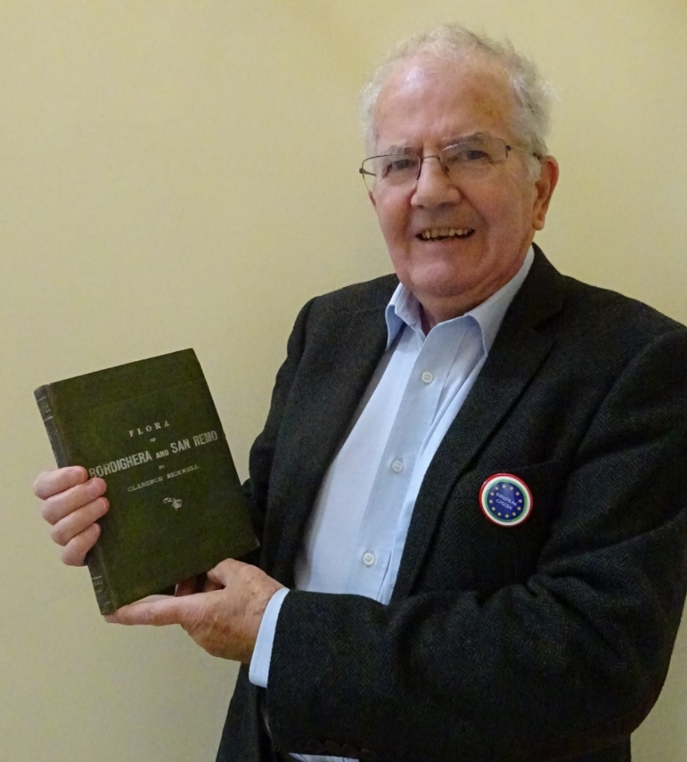

Click here for details of Clarence’s book and here for information about ‘Adopt LINN’

Note issued by the Clarence Bicknell Association www.clarencebicknell.com
19 June 2020

